A picture containing clipart

Description generated with very high confidence

Azure 103 Module 5

Hands On - 2

Azure Certification Training

[**support@intellipaat.com**](mailto:support@intellipaat.com)

**+91-7022374614**

**US: 1-800-216-8930(Toll Free)**

**Azure 103 Module 5 Hands On – 2**

**Create Public Load Balancer**

**Step 1:** Create two virtual machines within a single availability set and same virtual network.

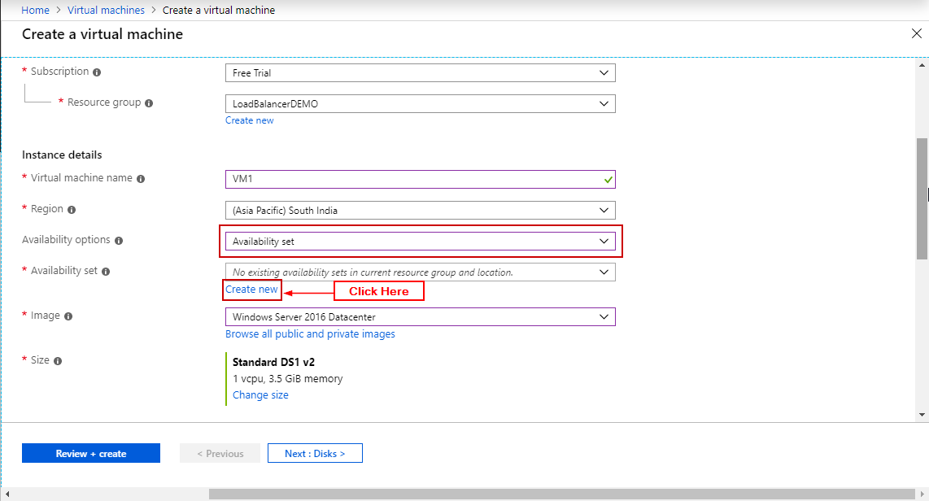

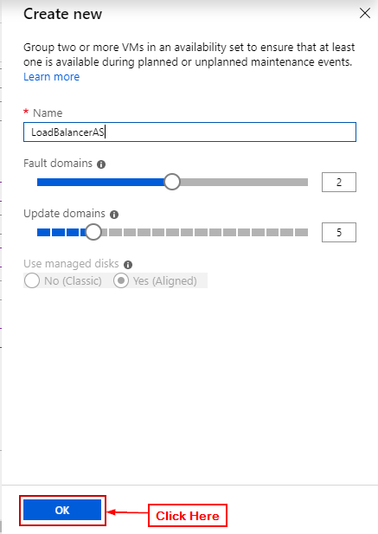

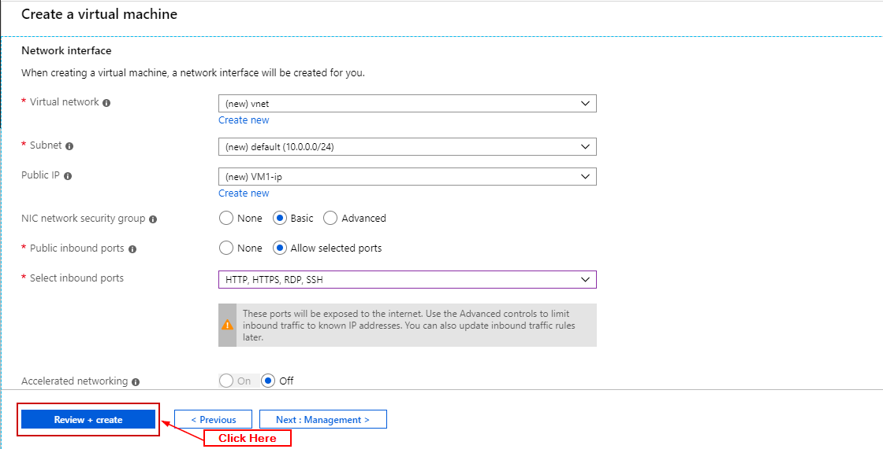

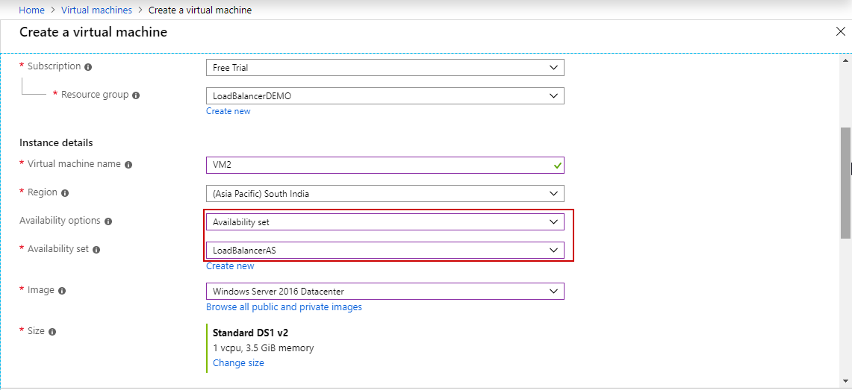

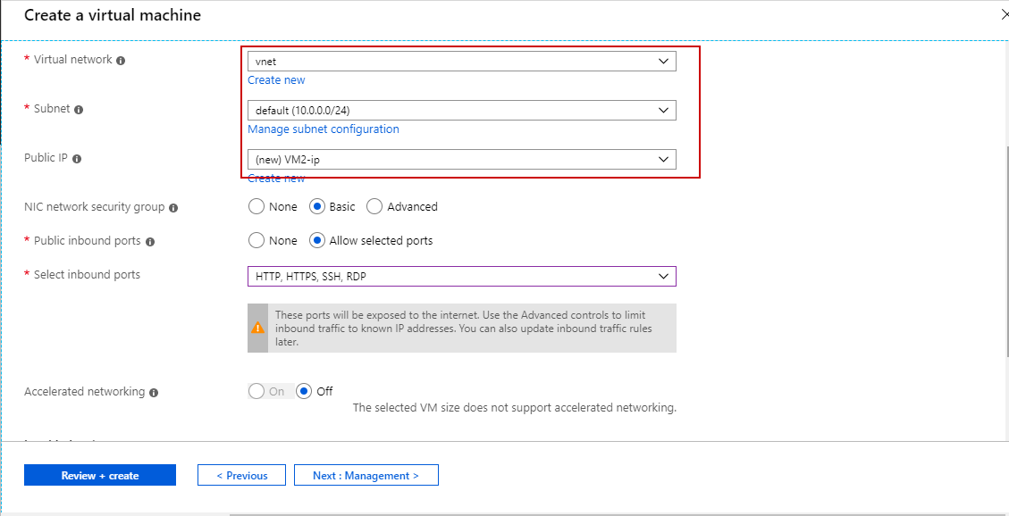

**Step 2:** In both virtual machines in Networking add an inbound security port rule for port 80.

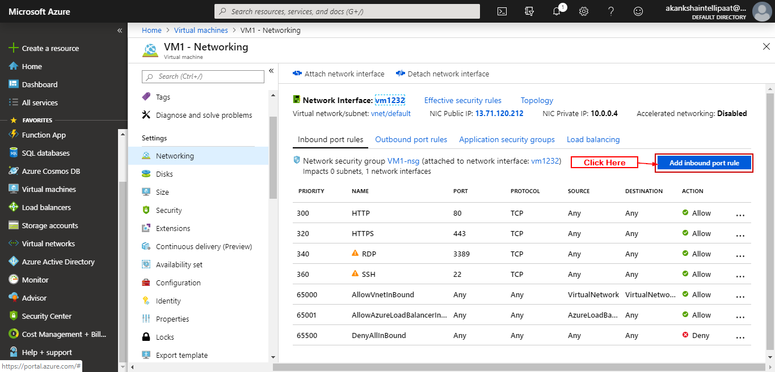

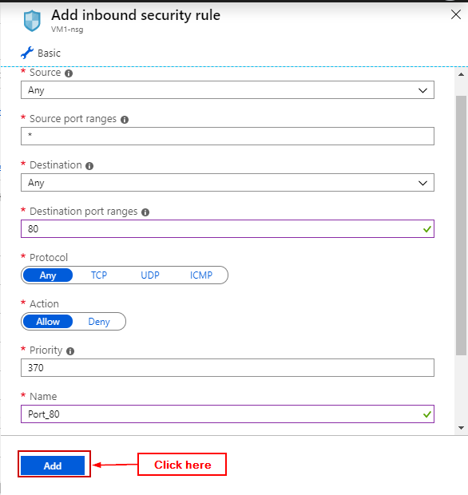

**Step 3:** Search load balancer and click on it.

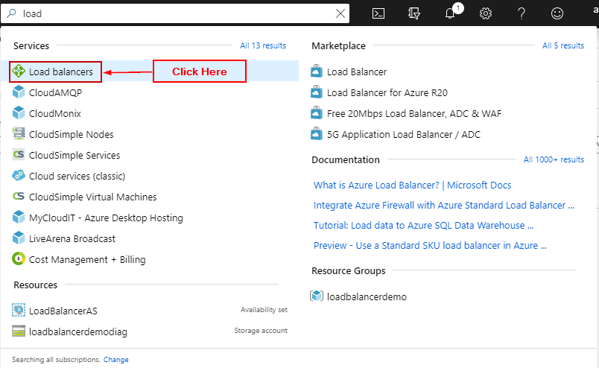

**Step 4:** Click on ‘+ Add’.

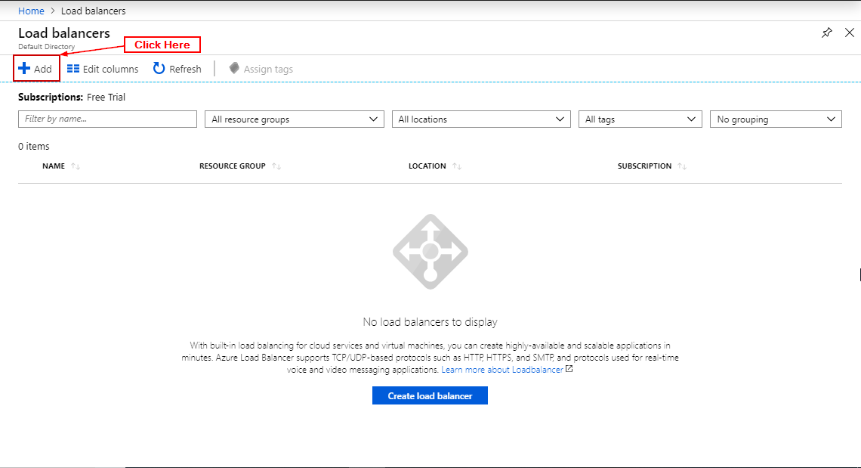

**Step 5:** Add details and click ‘Review + Create’.

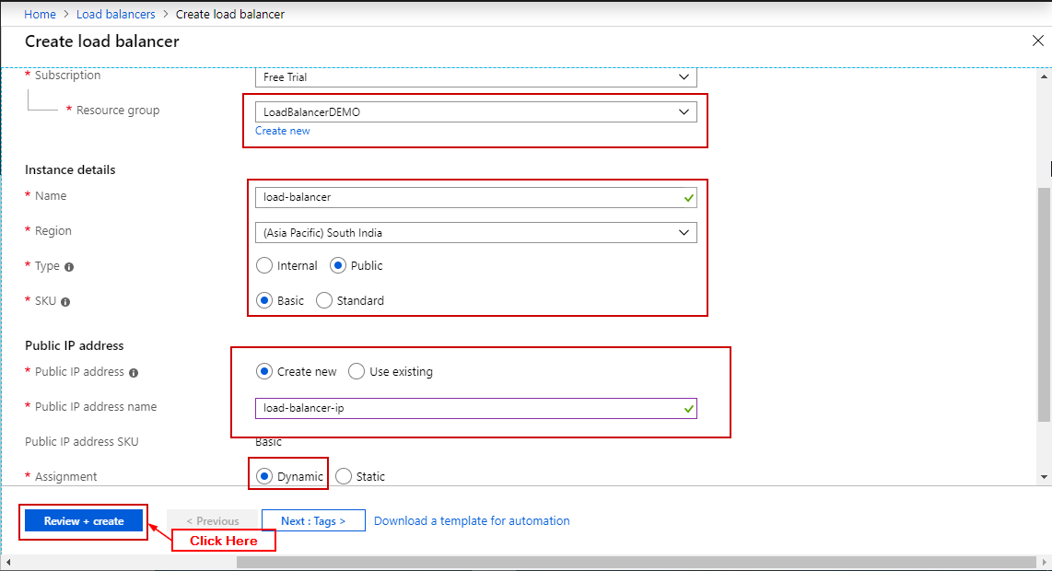

**Step 6:** Click on ‘Create’.

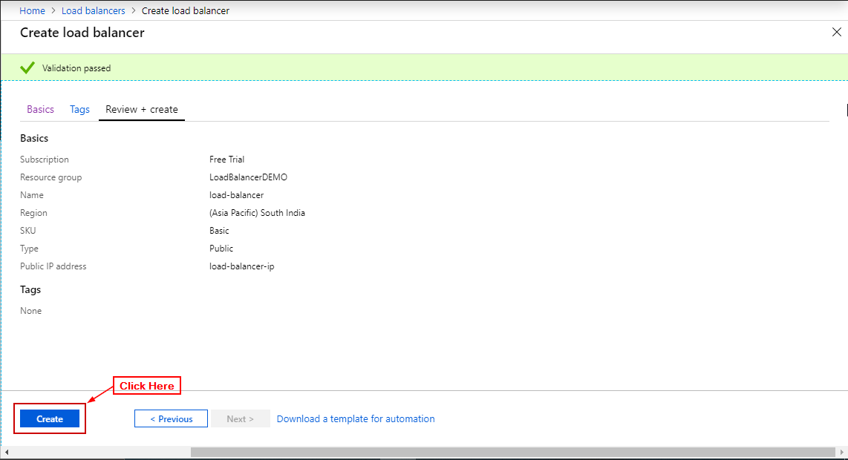

**Step 7** Open Load Balancer and click on FrontEndIP and click on the IP.

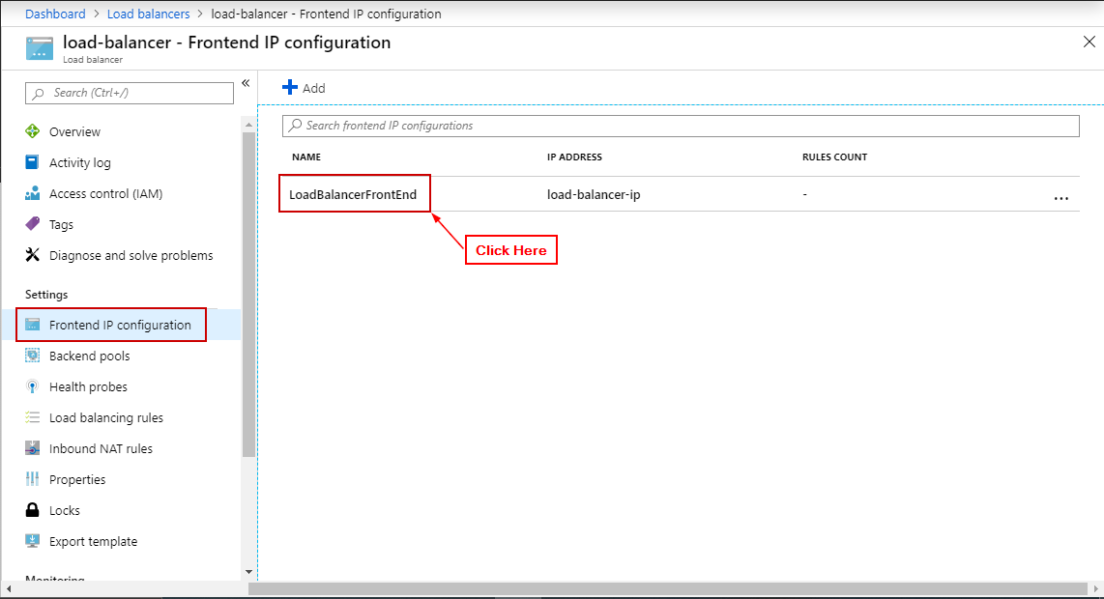

**Step 8:** Click on ‘+ Create New’.

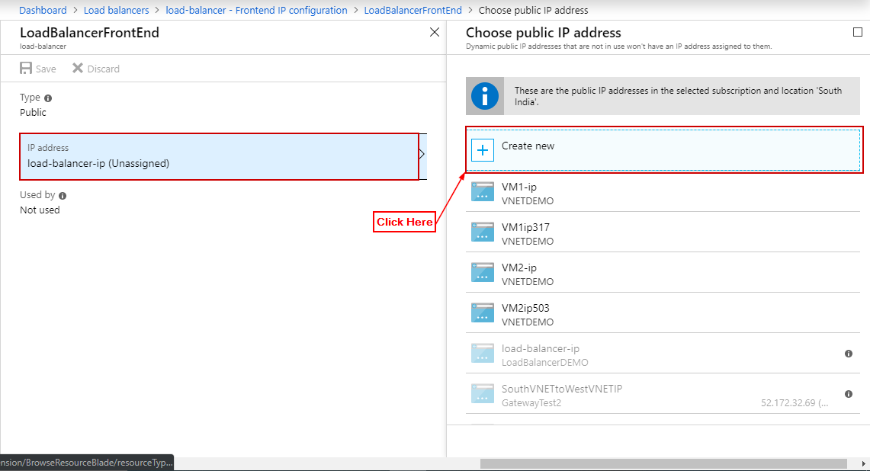

**Step 9:** Enter details click on OK.

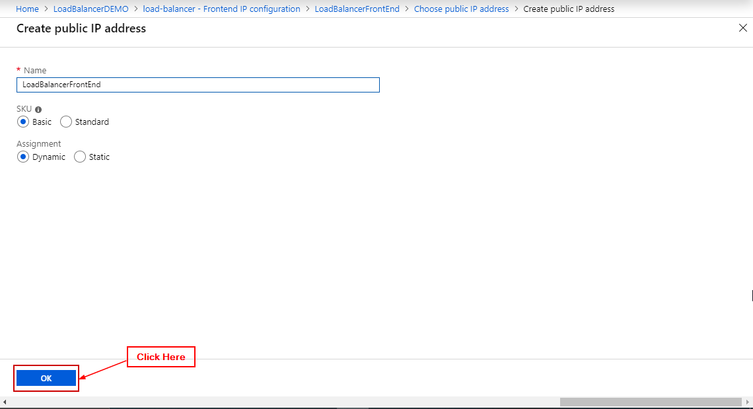

**Step 10:** Click on Save

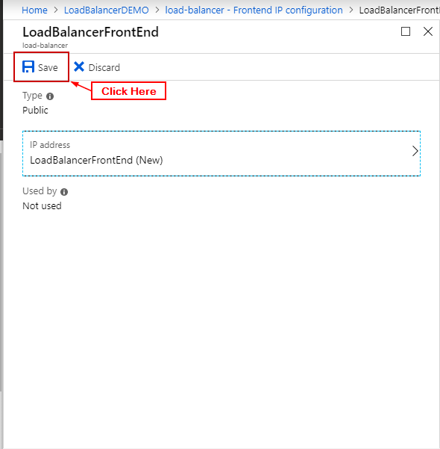

**Step 11:** In load balancer click on backend pools and click on ‘+ Add’.

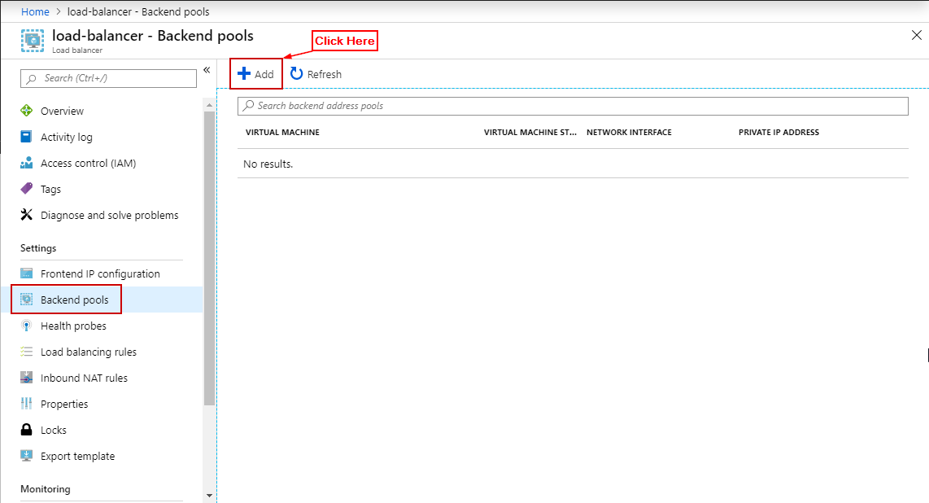

**Step 12:** Enter the details (Availability Set, in target IP Configuration add both VM’s and their IP) and click on OK.

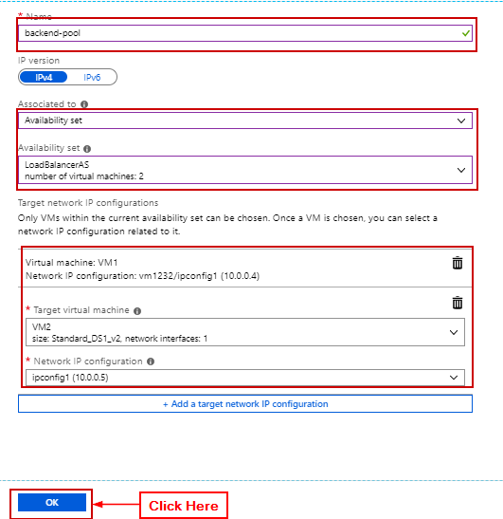

**Step 13:** In load balancer click on health probes and click on ‘+ Add’.

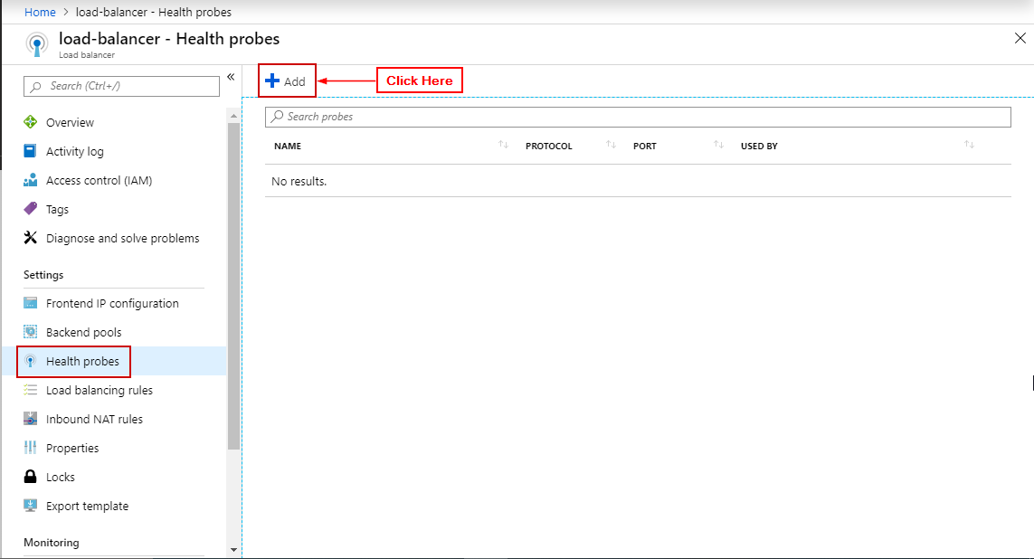

**Step 14:** Enter details click on OK.

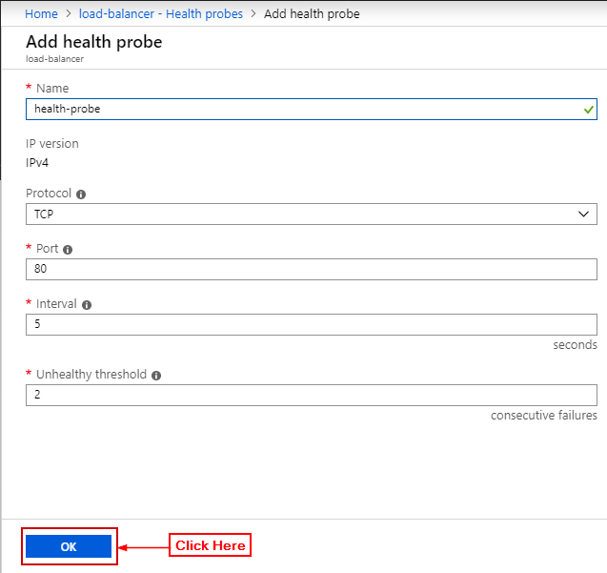

**Step 15:** In load balancer click on Load Balancing Rule and click on ‘+ Add’.

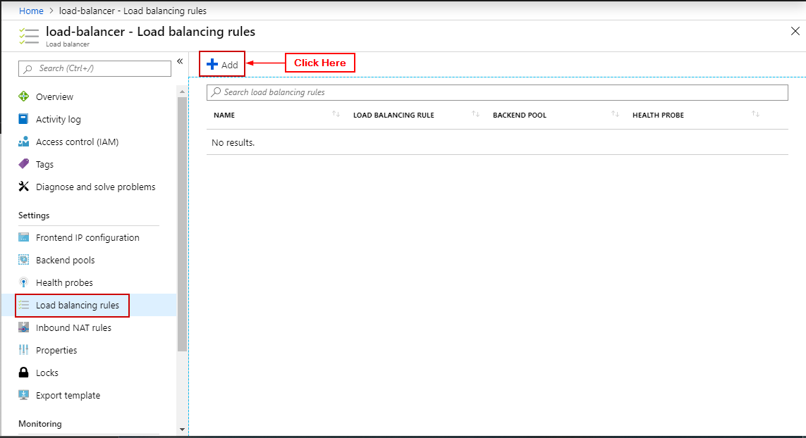

**Step 16:** Enter details click on OK.

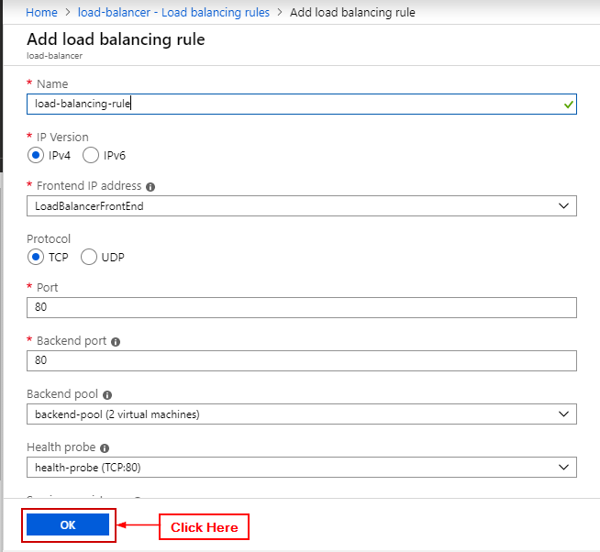

**Step 17:** Open load balancer and open the public IP Address.

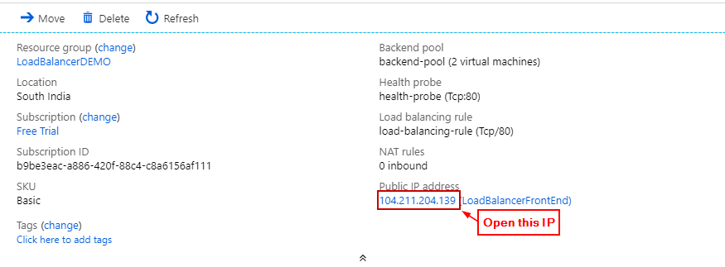

**Step 18:** Notice the website is being served by the load balancer.

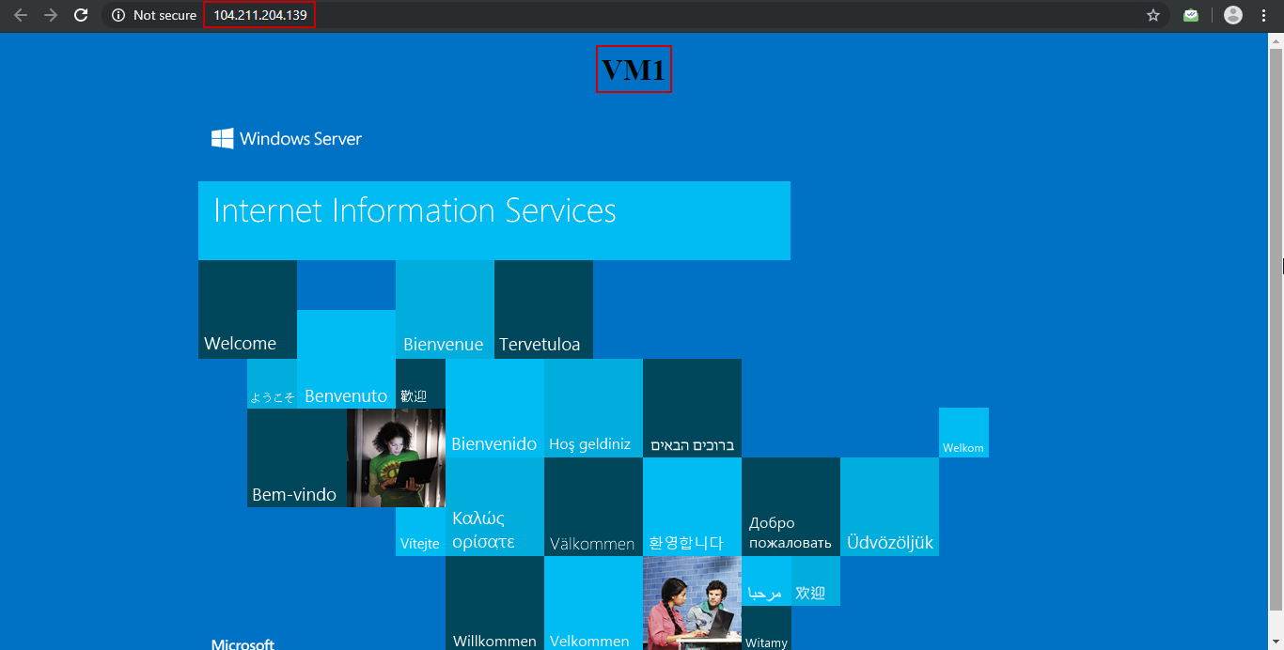

**Step 19:** Wait for a couple of minutes and refresh to see the website being loaded by other VM in the backend pool.

